***Exam hall seating arrangement system***



-- ***Shaik Afira***

51897475

***Abstract:***

*Exam Hall Seating Arrangement System is developed for the college to simplify examination hall allotment and seating arrangement. It facilitates to access the examination information of a particular student in a particular class. Mostly students are facing many problems for finding the exam hall and their seats respectively.* *This helps them to identify the floor or get directions to their respective halls without delays. The Students details have information about.It contains the name of the student, Hall Ticket No, Branch of the student and the hall number.*

*It contains four modules:*

*-Admin login*

*-Student register*

*-Room details*

*-Logout*

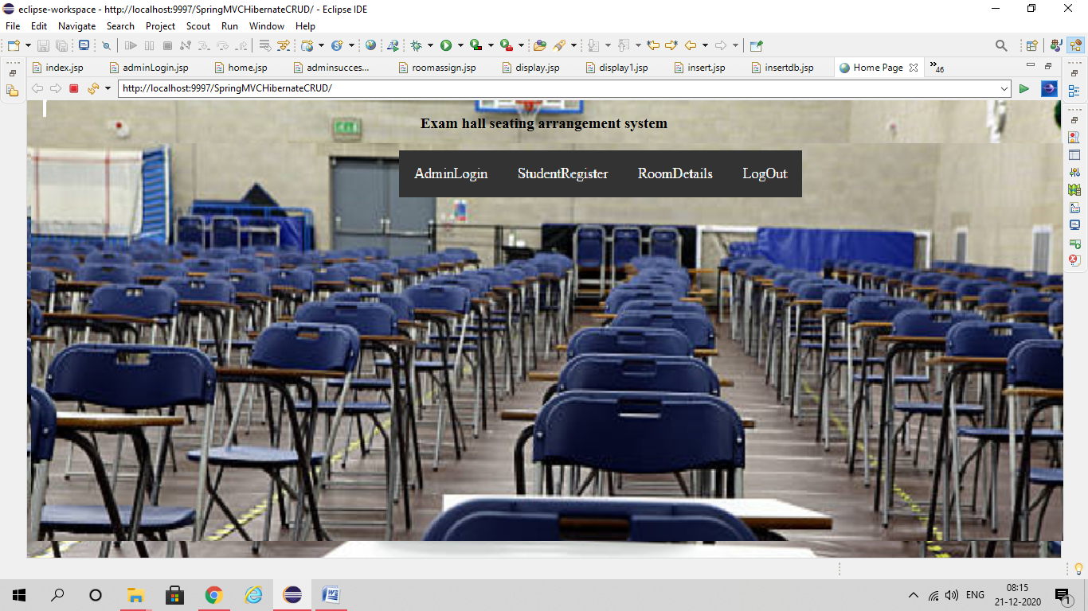

*Exam hall seating arrangement system has two users:*

*1.Admin*

*2.Student*

*Users and their roles:*

***Admin****: Among other users, admin can perform all actions and the actions include registering student s, add student, delete student, add rooms, delete rooms etc…*

***Student:*** *Student can check their exam halls by registering themselves with the help of admin.*

***Technologies used:***

*-Javascript*

*-MySQL*

*-Java(springs,hibernate)*

***Actions Performed****:*

***Login:*** *This page is used by admin..If he/she fails to login then redirected to home page itself.*

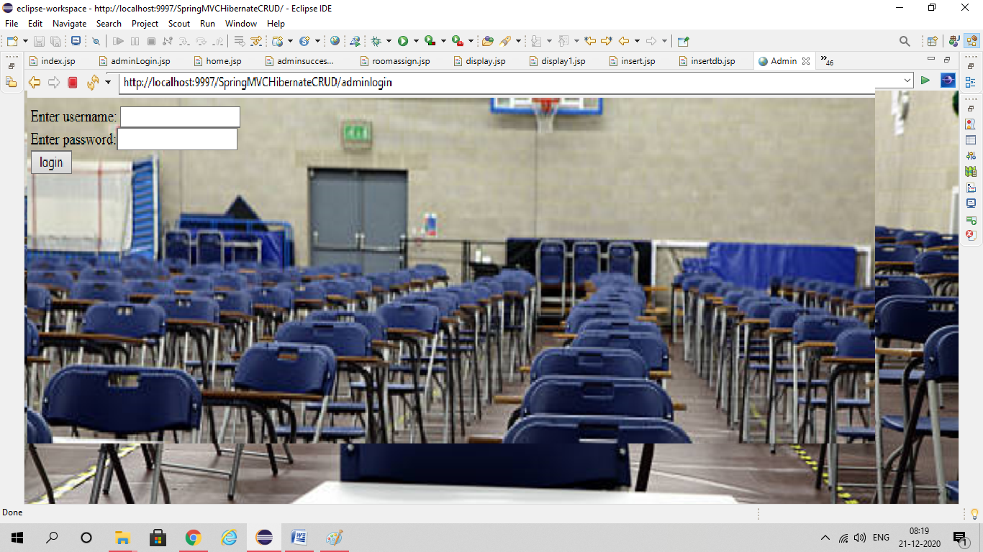

*Here is the first page where admin login enters and perform various actions.*

***Student Register****: Here Students who attends the examination will be registering by filling the details with the help of admin.*

*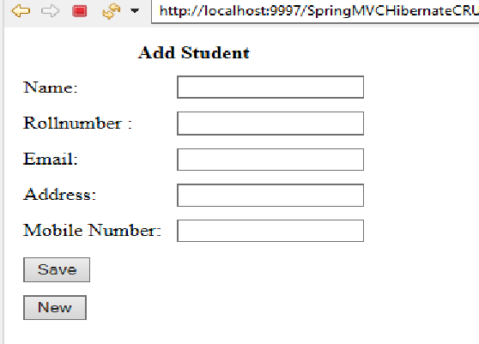If we click on save button after filling the details..It will show a “Data got inserted message”. If want register a new student, click on new button to save new student details.*

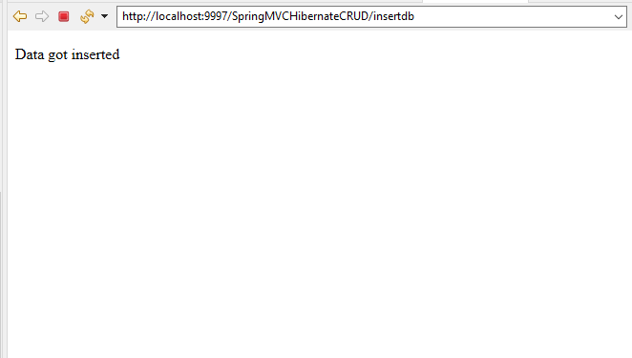

***Room Details:*** *In the room module, students who registers their names for attending the examination will display their room number with bench number and position.*

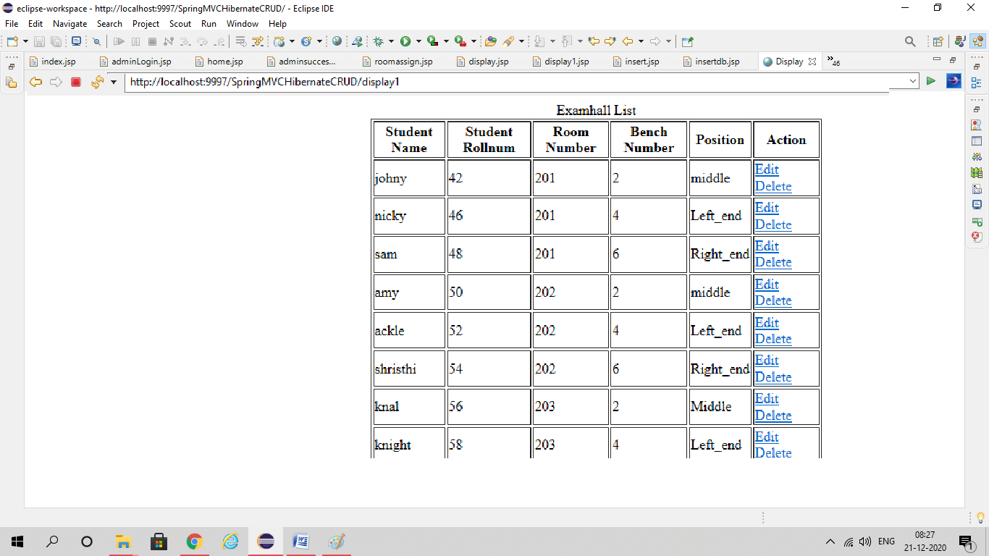

*The admin can edit/delete student details from the list by using action button.*

***Logout:*** *After all the actions are performed the admin can logout the session by clicking the logout button.*

**

